

དཔལ་ལྡན་འབྲུག་གཞུང་། སོ་ནམ་དང་ནགས་ཚལ་ལྷན་ཁག།
ནགས་ཚལ་དང་གླིང་ཀ་ཞབས་ཏོག་ལས་ཁུངས།
Royal Government of Bhutan
Ministry of Agriculture and Forests
Department of Forests and Park Services

MANAGEMENT AND MARKETING PLAN FOR NON-WOOD FOREST PRODUCTS
(Goney-Wambur Shingmin Tshokpa)

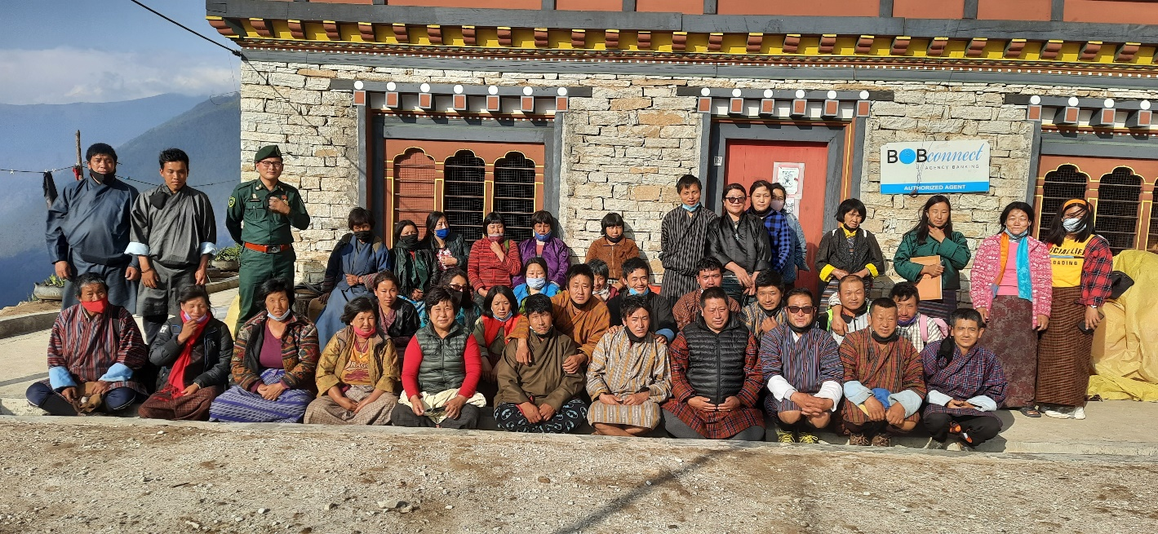

Tsenkhar Gewog
Lhuntse Dzongkhag

(Plan Period: August 2022-July 2027)

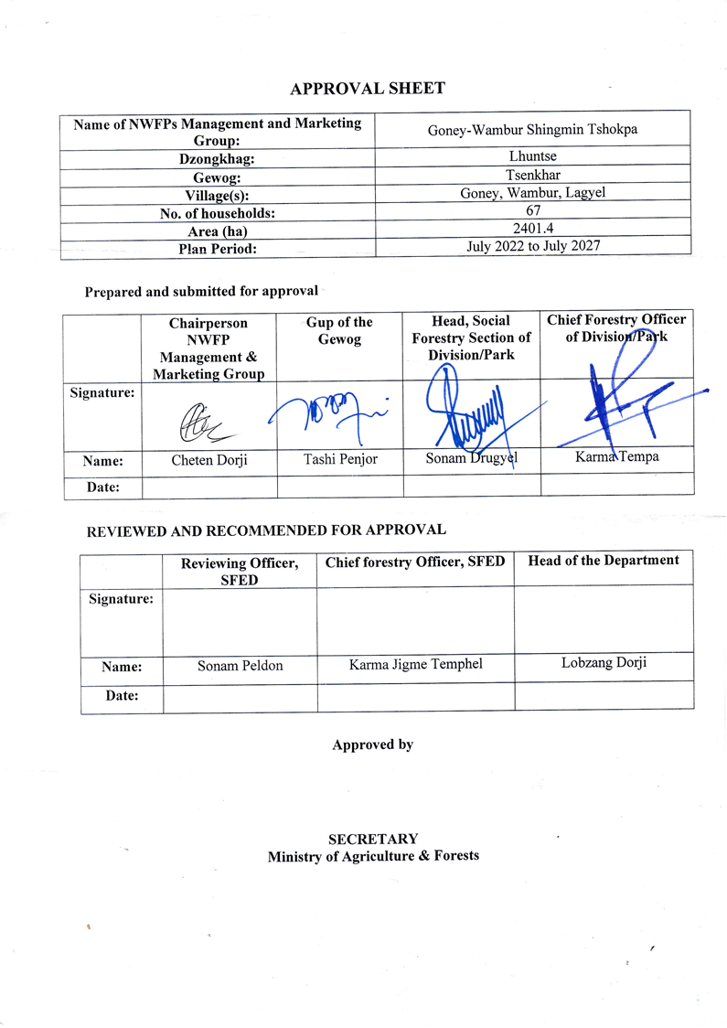

Table of Contents

PART A: MANAGEMENT AND MARKETING PLAN 1
1. Introduction 1
2. Objectives of Collection and Marketing of NWFP 2
3. Description of NWFPs 2
Table 1: Brief description of NWFP for commercial harvesting 3
Table 2: Harvesting guidelines and description for other NWFP 3
4. Maps of NWFP Collection Area 5
4.1 Map of the NWFP Harvesting Areas 5
4.2 Map of Borinda grossa and Daphne bholua Extraction 6
4.3 Land Use Map of NWFP Area 7
5. Sustainable NWFP Harvesting Prescriptions 8
5.1 Domestic purpose 8
5.2 Commercial purpose 8
Table 3: Harvesting prescription for sustainable harvesting of NWFP 8
6. Marketing and Sales Plan 9
Table 4: Marketing and financial projections 10
7. Marketing Arrangements 10
8. Resource Assessment 10
8.1 Borinda grossa 11
8.1.1 Field data collection 11
8.1.2 Data analysis 11
8.1.3 Calculation of Annual Harvesting Limits (AHL) 11
Table 5: Data analysis of B. grossa 12
8.2 Daphne bholua 13
8.2.1 Field data collection 13
8.2.2 Data analysis 13
Table 6: Data analysis for D. bholua 14
PART B: By-laws: Group Regulations and Norms 15
1. Members of the NWFP management & marketing group 15
2. Executive committee 16
2.1 Chairperson 16
2.2 Secretary 16
2.3 Treasurer 16
2.4 Resungpa 17
2.5 Compensation to the executive committee for marketing 17
3. Membership fee and other conditions 18
4. Community development fund and utilization of fund 18
5. Conflict resolution 19
6. Penalties 19
7. Benefit sharing 20
8. Meetings 20
9. Authority of the Department 20
10.Cancellation of NWFP Management Certificate 21
Annexures I: NWFP Member List 22
Annexure II: Block description for Borinda grossa 25
Annexure III: Bock description for Daphne bholua 26
Annexure IV: B. grossa data analysis 27
Annexure V: D.bholua data analysis 28
Annexure VI: Data Collection Pictures 29

PART A: MANAGEMENT AND MARKETING PLAN

1. Introduction
Bhutan is blessed with many NWFPs wherein the local community use it for self-consumption as well as for generating income since the time immemorial. The NWFPs as such plays vital role in improving livelihood of the people residing near and far from the forest. This forest resources could be source of conflict for the people as it is said to be ‘common pool resources’ and it may, at the same time exhaust if not managed carefully. Therefore, Department of Forest and Park Services have been helping the general public in managing resources and meanwhile making people to use the resources sustainably without detrimental effect to conservation.
Goney-Wambur is a chiwog under Tsenkhar Gewog which is located approximately 1300-2000 meter above sea level (masl). The chiwog is connected with feeder road, telephone, electricity and clean drinking water. It is 23 km drive from Gewog Centre, Phawn. The village experience warm summer and cold winter. There are 73 households in the chewog of which 63 households are member in the NWFP management and marketing group. They are mostly agrarian society depending on agricultural activities for their daily livelihood. The farming system is essentially subsistence and main staple food crop grown in the area are rice, maize, wheat etc. They also produce a wide variety of vegetables such as chilies, potatoes, cabbage, radish, beans etc.
The Goney-Wambur NWFP management area falls within Rongmanchu Forest Management Unit. The forest type in the community is both conifer and cool-broadleaved forest. The cool-broadleaved forests dominate the surrounding forest cover. The thick and dense forest coverage provides home to wide range of wild animals such as Wild Boar, Mask Deer, Barking Deer, Bear, Common Leopard, Fox, Dhole, Monkey and variety of birds species.
The non-wood products are distributed sporadically in small pocket of the area. There are total of 13 Non-Wood Forest Products (Table 1) found in the designated area and out of which, four species has economically potential viz. Paris pollyphylla (Jagpa Thogsumpa), Daphne bholua, Rubia cordifollia, Borinda grossa. Other NWFP products (other than those four products) are also found in the area but can be collected based on the market availability and demand. The potential of NWFP collection may not be in huge quantity, but if harvested and marketed judiciously by the community people it would help them to earn additional income. Approximately more than 5934 acres of adjoining forest area provides conducive environment for the community people to collect Non-Wood Forest Products for the Member of Goney-Wambur Shingmen Tshogpa.

2. Objectives of Collection and Marketing of NWFP
- To protect collection of NWFPs by the outsiders.
- Sustainable harvesting and management of Non-Wood Forest Products.
- To generate income through sale of Non-Wood Forest Products.

3. Description of NWFPs
The forest of Goney-Wambur has varieties of NWFPs such as Paris pollyphylla (Jagpa Thogsampa), Borinda grossa (Baa), Rubia cordifollia (Tsoe), Dephne bholua (Deynap), Onosma hookeri (Muhtsi), Pogostemon amaranthoides (Namda), Diplazium sp (Fern), Cymbidium spp (Olachoto), Acorus calamus (Shuda), Elantosteme lineolatum (Damroo), Emblica officinalis (Amla), Nephrolepsis cordifolia (Khowchi khiwchi), Viscum articulatum (Ngashing Jorma), Otochilus lancilabius (Olatse). The most of the NWFPs are found in upper ridge of Wambur and Lagyel village which is dominated by broadleaved forest while Amla and Khowchi is found in lower elevation especially in Chir-pine dominated area. The Borinda grossa and Daphne bholua are found abundantly in Lagyel area and local people extract Borinda grossa for both domestic and commercial purposes. The Daphne is also one of the product that has economical prospect in the area although people have not yet collected. . The group mainly focuses on collection of Borinda grossa, Rubia cordifolia, Daphne bholua and Paris polyphylla as the main products for commercial marketing and Daphne bholua will be collected only if there is demand from the buyers/traders. NWFPs such as ferns, mushroom, etc will be collected mainly for domestic purposes and for commercial if there is demand.

Table 1: Brief description of NWFP for commercial harvesting
NWFP species | Harvesting area(s) name | Part harvested | Use purpose (traditional & others) | Harvesting season(months) | Estimated quantity that can be collected in a year
Borinda grossa | Rewapang Juug, Sadhu Brangsa, Rashu Goenpa | Culms | Weaving bamboo mates/handicraft | December to February | 1000 culms
Rubia cordifolia | Lagay, Wambur, Kiphu, Goney | Upper part of plant | red dye and medicinal | November to February | 1500 kg
Paris polyphylla | Damtshang, Rewa, Phuningla  Duptsi Gonpa, Shogtshangla | Rhizome | Curing burns, cuts, diarrhea, dysentery, fever, stomachache | October to November | 60 kg
Daphne bholua | Lagay, Tsanchotla, Goney | Bark | Traditional paper | March to June | 1400 kg

Table 2: Harvesting guidelines and description for other NWFP
Sl. No | Name |  | Parts Used | Purpose | Time of Harvesting (month) | Harvesting Guideline
 | Scientific | Local
1 | Onoma hookeri | Muhtsi | Roots | Religious purpose | September to December | Dig up only matured rhizomes.  Leave the mother plant intact with small part of root in the soil.  Harvest rhizome during harvesting season.  Do not uproot entire plant.
2 | Pogostemon amaranthoides | Namda | Leaves | Vegetable | May to September | Cut tender shoot only.  Retain 1% of mother plants in clump
3 | Diplazium spp | Fern | Shoot | Vegetable | June to September | Cut tender shoot only.  Retain 1% of mother plants in clump
4 | Cymbidium spp | Olachoto | Tender parts | Vegetables | October to January | Cut tender shoot only. Retain mother plants in clump
5 | Acorus calamus | Shuda | Roots | Medicine | Whole year | The plant is uprooted either by hand or using hoes, cut the root parts and plant back the aerial stem
6 | Elantosteme lineolatum | Damroo | Leaves | Medicine and food | 9th to 12th Bhutanese month | Cut tender shoot only
7 | Emblica officialnalis | Amla | Leaves | Medicine/food | January to March | Plucking by hand or shaking with small stick  Picking fruits from the forest floor.  Don’t cut down tree in order for fruits to collect.
8 | Nephrolepsis cordifolia | Khowchi khiwchi | Root | Medicine | Whole year | The plants are uprooted either by hand or hoe.  Retain few shoots as mother trees
9 | Viscum articulatum | Ngashing Jorma | Shoot |  | March to May | The plants has to be cut 20cm above ground (retain few plants as seed trees)

4. Maps of NWFP Collection Area

4.1 Map of the NWFP Harvesting Areas
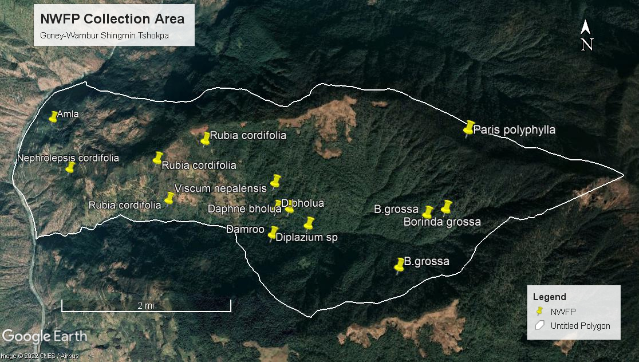

4.2 Map of Borinda grossa and Daphne bholua Extraction
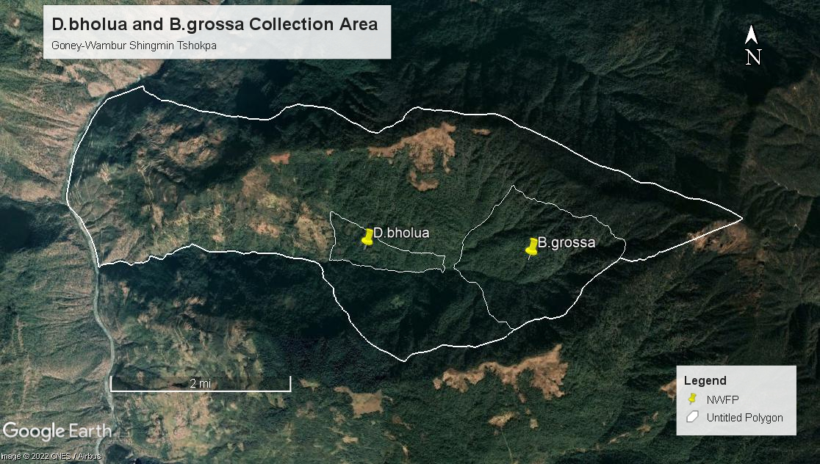

4.3 Land Use Map of NWFP Area
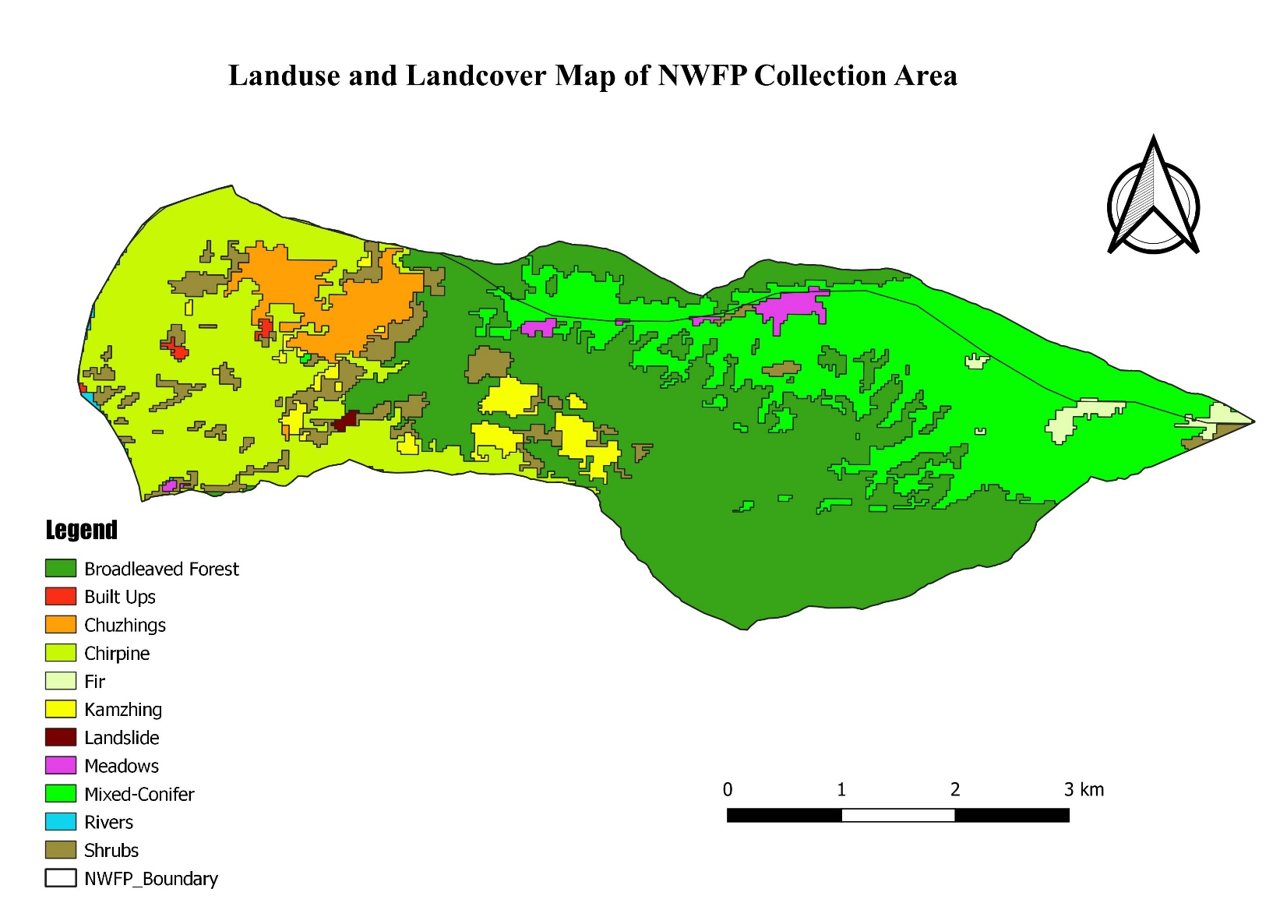

5. Sustainable NWFP Harvesting Prescriptions

5.1 Domestic purpose
Any individuals harvesting NWFPs for domestic consumption should inform the Chairperson before proceeding for collection.
Harvesting of NWFPs for domestic purposes can be done any time with the realization of Royalty. Meanwhile, members shall comply with the restrictions (Reedam/Laadam) imposed by the village.
Maximum harvesting limit of Borinda grossa for domestic purposes is 200 numbers per household/season.
NWFPs like mushroom, damroo and fern for domestic consumption can be harvested anytime as per the requirement of the individual members.

5.2 Commercial purpose
Commercial harvesting should be done together involving all the members after obtaining collection permit from nearby forest office.
Any members willing to harvest the Paris polyphylla, Rubia cordifolia and Borinda grossa for commercial/domestic purpose, should inform the Chairperson before collection so that the chairperson could process for obtaining the collection permit.
The commercial extraction of NWFPs shall be done only by the members; the outsiders are strictly restricted for commercial extraction.

Table 3: Harvesting prescription for sustainable harvesting of NWFP
NWFP species | Harvesting prescription for sustainable harvesting
Borinda grossa | Cut culm at the base or at first long internodes above the nodes.  Leave bamboo shoot or culm of less than one year old intact.  Do cut culm when new shoots are sprouting.  Harvest culm in condense culm in u shape
Rubia cordifolia | Use sharp scissors for the harvesting of the upper parts of the plants.  The plant has to be cut from 5cm above the ground.  Do not uproot entire plants.  Leave at least 10% of the plants without collecting to ensure natural regeneration.
Paris polyphylla | Dig up only mature rhizomes.  Leave the mother plant intact with small part of root in the soil.  Harvest rhizome on during harvesting season.  Do not uproot entire plant.
Daphne bholua | Cut the plant 10cm above ground level.  Cut stem that are more 3cm in diameter.  Do not damage the remaining young stands/seedlings or saplings

6. Marketing and Sales Plan
- The NWFPs will be sold to the buyers/traders by the group at least involving one fourth of the member.
- No individual shall be permitted to sell without the consent of the group members.
- Standard/Harvestable size (2-4 cm) and length (5 m) of Borinda grossa for commercial purposes have to maintain. One back load should consist of 30-40 nos. for men and 15-20 nos. for women and children. It shall be sold at a rate of Nu.6/- which includes the royalty for outsiders and Nu.2 for group members.
- One kg of dried Daphne bholua shall be sold at Nu.50/- including the royalty irrespective of quality.
- Cost of Paris polyphylla has been fixed at the rate of Nu.2500/ kg including the royalty.
- The dried Rubia shall be sold at the rate of Nu.50/- per kg and shall not sell the fresh Rubia.
- Permit fee and royalty of NWFPs should be paid as per the royalty of the DoFPs.
- The other NWFPs listed in the annexure shall be sold as per the commercial rate fixed by the DoFPS.
- All the NWFPs shall be sold to the trade license holder only.
- The amount received or earned from the sale of NWFPs will be deposited in the group account.
The marketing and sales plan for different types of NWFPs that are to be collected by the group, its potential markets where the group shall sell products with approximate quantity, price per unit and the total value of the expected sales are described in the table below:

Table 4: Marketing and financial projections
NWFP |  | Potential market | Estimated quantity for sale per season (unit) | Expected price per unit | Total (Nu)
Borinda grossa |  | Local Market | 10000 culms | 6/- | 60,000
Rubia cordifolia |  | Within Bhutan/India | 7500 kg | 50/- | 3,75,000
Paris polyphylla |  | Within Bhutan | 300 kg | 2500/- | 7,50,000
Daphne bholua |  | Local market | 7000 kg | 50/- | 3,50,000
Total Amount |  |  |  |  | 1,535,000
Note: The marketing and sales plans for NWFPs list in the above table (qty) is estimated for 5 years.

7. Marketing Arrangements
The Chairperson shall collect demand of NWFPs before onset of any product collection season with support of concerned Forestry Officials. Then, the marketing of NWFPs will be organized and arranged as per the procedures given below:
- Marketing of products will be always group based. However, the Chairperson will arrange selling point either at Lhuntse, Mongar or in nearby villages and towns. The members will collect forest/wild vegetable items from different blocks on rotational basis. It will be taken to vegetable market along with other agriculture products. OR
- Members are not allowed to accept any advance payment from buyers at any circumstances as such practices deteriorate quality of products and also encourage over exploitation of resources.

8. Resource Assessment
The resource assessment of two potential NWFP viz. Borinda grossa and Daphne bholua in the area has been carried out to estimate the amount that can be harvested on sustainable basis from the area.

8.1 Borinda grossa
The culms of Borinda grossa is long, straight and it is useful for weaving durable fencing mats and roofing mats, baskets, containers, hats.

8.1.1 Field data collection
Borinda grossa resource assessment was carried at Lagyel area following the stratified sampling method in which area is divided into different blocks according to the location and density. The plant is measured randomly in the chosen sample plots. The quantitative assessment was carried out by laying the sample plots of 10 m x 25 m along the slope direction. From each sample plot, the bamboo stock is measured including the condition of the clump, number 1+ year, 2+ year and 3+ year culms and the number of culms that the local people consider harvestable. These harvestable culms are mostly 1+ year, 2+ years are in good health and are straight, have length of five m and a diameter of 2 to 4 cm. Resource assessment was done by collecting the data about the locations and quantities of species present in the area. Based on the results of this survey, the area is divided in to 3 blocks according to the availability of the resources on the Google map. Out of 3 blocks, the farmers has decided and agreed to collect the Borinda grossa from the block alternatively. The members also decided to collect Borinda grossa based on AHL and as per the guidelines.

8.1.2 Data analysis
Data collected from the sampling plots were entered in the excel sheet and then sorted cleaned for further analysis work.

8.1.3 Calculation of Annual Harvesting Limits (AHL)
AHL: 0% of the shoots +33% of the total stock of 1+ year and 2 + years old culms+70% of the 3+ years old culms (Table 5).
Based on the results of the inventories, the total harvestable culms were calculated for each sub block. The AHL for 1+ year and 2+ years old culms from the clump was set at 33% of total culms. This will ensure the regeneration of the species because the shoots of less than 1 year old culms will be retained and provide the 1+year culms for following year. There will be also enough 1 + year culms to provide 2 + years old culms for next season. Meanwhile, 70% of 3 + years culms can be harvested and some will be left in the area to provide physical support to the younger culms. Based on the above AHL calculations, people decided to follow the following conditions;
- Maximum of 33% of 1+ year and 2+ year old culms per clumps will be harvested and 67% will be left intact in the area for regeneration.
- 70% of 3+ years old culms will be harvested and rest will be left in the area to provide physical support to the younger culms.

Table 5: Data analysis of B. grossa

8.2 Daphne bholua
Daphne bholua (Deynap) is a shrub of 1-3.5 m in height and occurs in evergreen oak, spruce, hemlock, fir and blue pine forests at an altitude of 1950-3400 m. It is used for the production of traditional paper. D. bholua is the only Daphne species that is also used as an ornamental plant because of its strong fragrant flowers.

8.2.1 Field data collection
The resource assessment for D.bholua is carried out at Goney and Lagyel area following a systematic sampling design with the sampling plots of 10 m x10 m. In each sampling plot only the diameter of the stem was recorded. Research has shown that there is a direct correlation between the diameter and the total dry bark yield, thus more data are not needed. The diameter of Deynap and Deykap were measured at 10 cm from the ground level, referred to as D10. The diameter of all stems more than 1 cm at D10 were recorded. Plants with a smaller diameter were recorded as < 1 cm. The diameters of multi-stemmed plants were converted into a single stem diameter. Based on this single stem diameter, the total dry bark weight were estimated based on a formula. Dead plants are not measured. A plant is declared dead, when it has no green leaves during vegetation time. If it is estimated that the plant has lost more than half of its bark, it is also not measured; if less than half of the bark is lost, the plant is measured as usual.

8.2.2 Data analysis
Based on research carried out by C. Hadorn and P. Wangda (1999), a formula was developed to estimate the total dry bark yield of Deyknap, Daphne bholua and Daphne sureil (there are no data available about the other Daphne species) for whole of Bhutan:

Wd = 0.02559*D10^2.27221
In which Wd is the estimated total dry bark weight in g, and
D10 is the diameter at 10 cm from the ground in mm

Based on this formula the total dry bark weight were estimated as a function of the diameter at 10 cm from the ground. According to the same research of C. Hadorn and P. Wangda (1999), some 47% of the total dry bark weight cannot be used and is considered as waste bark (for all diameters), the remaining 53% is the usable bark. As per the calculations the total dry bark weight which can be collected is 7121644.98 g (7121.6 kg).

Table 6: Data analysis for D. bholua

PART B: By-laws: Group Regulations and Norms

1. Members of the NWFP management & marketing group | Village |  | Number of member households | Gewog
 | Goney |  | 3 | Tsenkhar
 | Lagay |  | 7
 | Wambur |  | 50
 | Total |  | 63
Responsibilities and rights of members:
- All the members shall be responsible for sustainable management of NWFPs.
- The NWFPs shall be harvested during suitable season as prescribed in management plan.
- The NWFPs group members shall follow and respect the instruction of executive members.
- All members shall be vigilance for illegal harvesting of NWFPs by non-members and report to forest office/executive members.
- All the group members have right to harvest NWFPs and market as per this plan.
- The members will collect NWFPs as per the directives of the Chairperson based on demand of the trader/buyers but not exceeding the annual harvesting limit.
- Members should inform the Chairperson/Forestry Official of any person extracting rural timber from NWFP harvesting area so as to stop the illegal harvesting of the NWFPs.

2. Executive committee
2.1 Chairperson |  | Name of Chairperson: Cheten Dorji
Responsibilities of Coordinator/ Chairperson:
- The Chairperson has power to impose the fines and penalties if any members do not follow his instruction (meeting, timing).
- Chairperson shall obtain the NWFPs collection permit from forest office during the collection season.
- Inform or announce the date of NWFPs collection to each member.
- Should coordinate the NWFPs harvesting.
- Shall contact with the buyer/traders on the required quality of the NWFPs and inform the members accordingly.
- Shall look for the buyers/traders.
- To chair/coordinate all meetings related to this plan.
- Resolve disputes and conflicts among members.
- Take care of overall financial arrangements.
- Attend/participate trainings/workshop/study tour when called.

2.2 Secretary | Name of Secretary: Jambay Dorji
Responsibilities of Secretary:
- Maintain/Keep the sale records.
- Maintain the minutes of meeting.
- Attain/participate trainings/workshop/study tour when called.
- Assist the Chairperson.
- Keep detail record of NWFPs harvest and submit to Chairperson

2.3 Treasurer | Name of Treasurer: Kinzang Tshomo
Responsibilities of Treasurer:
- Maintain cash transaction records.
- Collect membership fees, incentives/compensation fees and deposit in bank
- Look overall financial transaction in collaboration with the Chairperson and Secretary.
- Officiate Secretary.
- Keep detail record of NWFPs sale data.
- Present account statement to the group during meeting
- Issue money receipt after collection of fines and penalties

2.4 Resungpa | Name of Resuups: Geley Wangchuk, Nidup Wangdi, Sonamla, Tenzin Choiphel, Thinley Wangchuk
Responsibilities of Resuups:
- Patrol the NWFP area and report to Chairperson.

2.5 Compensation to the executive committee for marketing | The group members discussed and decided to compensate the executive members with incentives of Nu.250 whenever there is sale of NWFPs. The incentives will be paid from the amount received from the sale of NWFPs which are extracted only from their Jurisdiction. If the group buy products from other areas, the compensation shall not be paid to any executive members.

3. Membership fee and other conditions | - Each member shall contribute Nu.150/- once in a year as a membership fee and shall be collected during the annual meeting.  - Any new member shall pay 5% of the total amount collected till date  - The fund will be deposited in the bank in the name of group counter signed by coordinator, secretary and treasurer.  - Anyone wishing to withdraw from the group will have to put application stating all the reasons and no objection in future. The decision will be made during meeting to leave the group.  - In unfavorable situation if one member wish to resign he/she will be allowed with equal benefit sharing.  - Once any member who had resigned from the group again wishing to join group will not be entertained. Any collection NWFP within the designated area is prohibited for them.

Community development fund and utilization of fund | The group decided not to have community development fund separately. The amount received or earned from the sale of NWFPs will be fully deposited in the group account which is already maintained. In any community based developmental activities or for spiritual matters, the group members will discuss and make the fund arrangements thereof. During such critical instances, the discussion shall be carried out with not less than 50% of members.

5. Conflict resolution | - Conflicts or disputes within the NWFP Management Group, which cannot be resolved by the group members shall be forwarded to the Chairperson for settlement.  - If the case cannot be resolved, it shall be forwarded to the Gewog Administration via Chiwog Tshogpa.  - In case there is a conflict between the NWFP Group and outsiders, the case shall be forwarded to the Divisional Forest Office and Gewog Administration by the Chairperson.

6. Penalties | - If any member sells the NWFPs directly to the traders without the notice of the group executive committee members shall be penalized as per the FNCRR, 2017.  - If the non-members are found doing illegal/taking of NWFPs shall be dealt as per the FNCRR, 2017.  - The group members shall sell the NWFPs to the valid trade license holder only, if not the group shall be penalized as per the FNCRR, 2017.  - The annual meeting shall be conducted on 30th month of December. Any members remaining absent in meeting should pay Nu.500/-as per the local village fine rules.  - If the committee members fail to attend the meeting, he/she shall be levied a fine of Nu.700. The collected amount shall be deposited in the group saving account. However, during the times of death and sickness consideration will be made.  - If any executive member’s misuses the group fund, he/she has to pay double the amount within the date line given by the group.

7. Benefit sharing | - The group fund will be shared equally among the members  - The group members are not allowed to collect NWFPs for individual marketing  - The collection of NWFPs by outsider is strictly prohibited  - Only small quantity is allowed to collect for self-consumption

8. Meetings | The group members will have one time meeting in a year which will happen on last week of December month. The group decided to conduct meeting at Wambur in Treasurer’s residence as it falls in center of the NWFP collection area. Should there be any ad-hoc meetings, the Chairman will inform the group and conduct at any time.

9. Authority of the Department | As per Chapter III, section 155 of FNCRR, 2017, the Department shall:  - Suo moto or on the request by the Non-Wood Forest Product Management Group (NWFPMG) take action against violator of the Act, Rules or Management Plan;  - Inspect, monitor, review the records of and otherwise supervise the activity of the NWFPMMG; and  - Take action including cancellation of the NWFMMG certificate if the NWFMG or any of its members who violate the provision of the Management Plan or any provision under this Chapter

10.Cancellation of NWFP Management Certificate | As per Chapter III, section 156, 157 & 158 of FNCRR, 2017:  - The certificate shall be cancelled, if the performance of NWFMG is not as per prescriptions of the approved management plan or the sustainability of the resource is not ensured  - In the event the members of the NWFMG decide to cancel NWFP Management certificate in accordance with this Rules, the NWFP Management Certificate shall be deemed cancelled on the date of such decision being notified to CFO in writing and the NWFMG shall surrender the Certificate to the Department  - The CFO shall have the right to enquire about the reason for such cancellation to ensure that no offence has been committed and shall notify the NWFMG on the cancellation of the certificate.

Annexures I: NWFP Member List
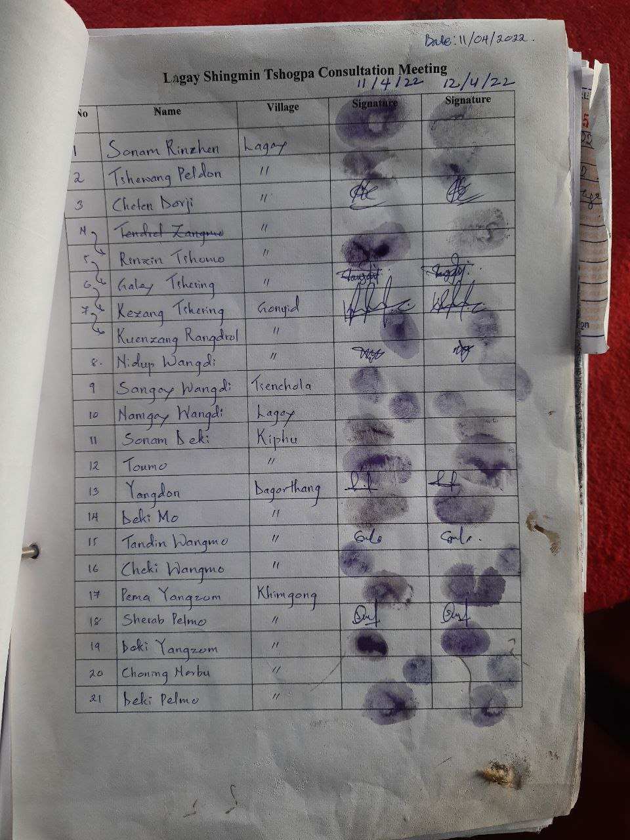
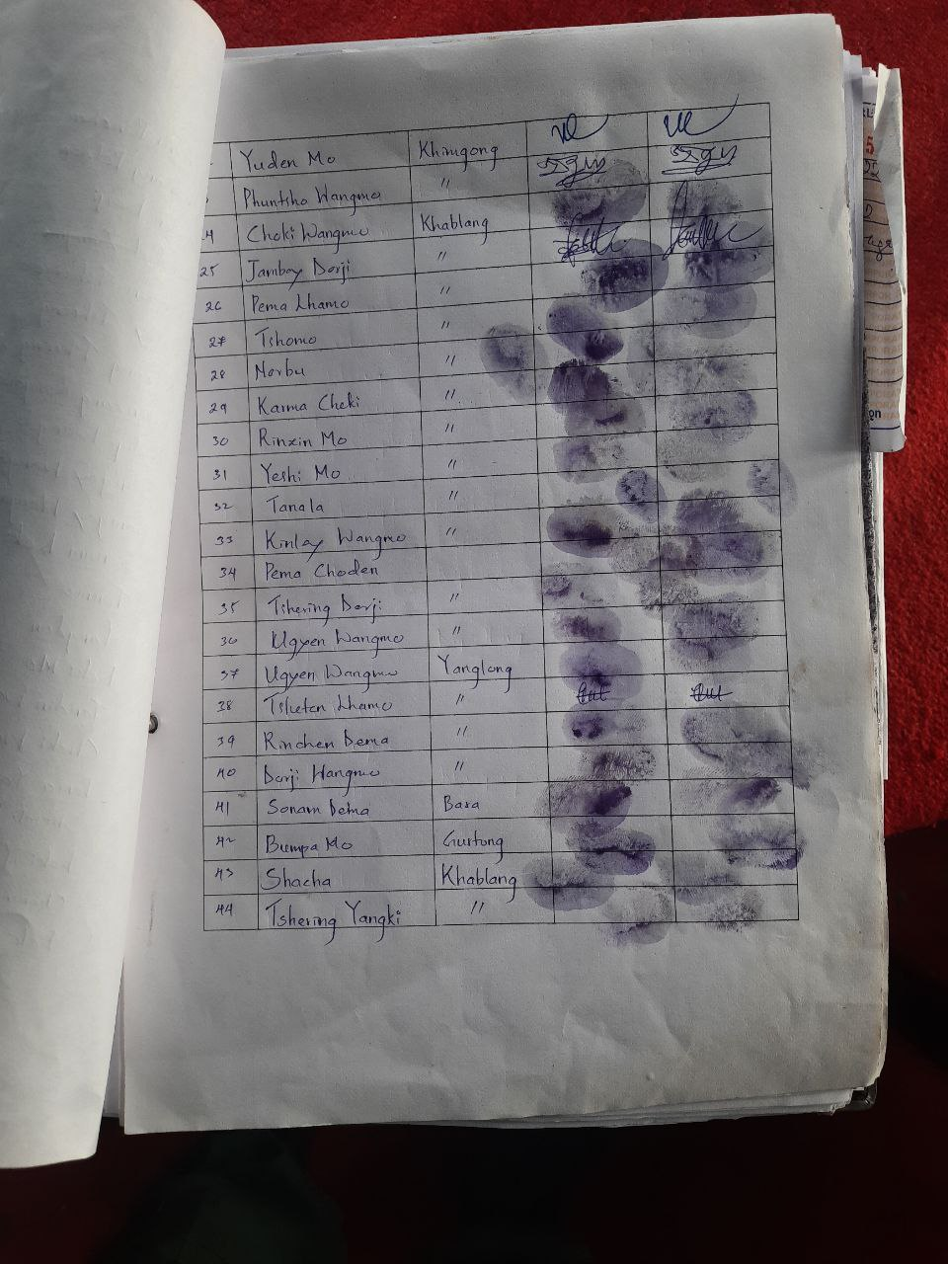
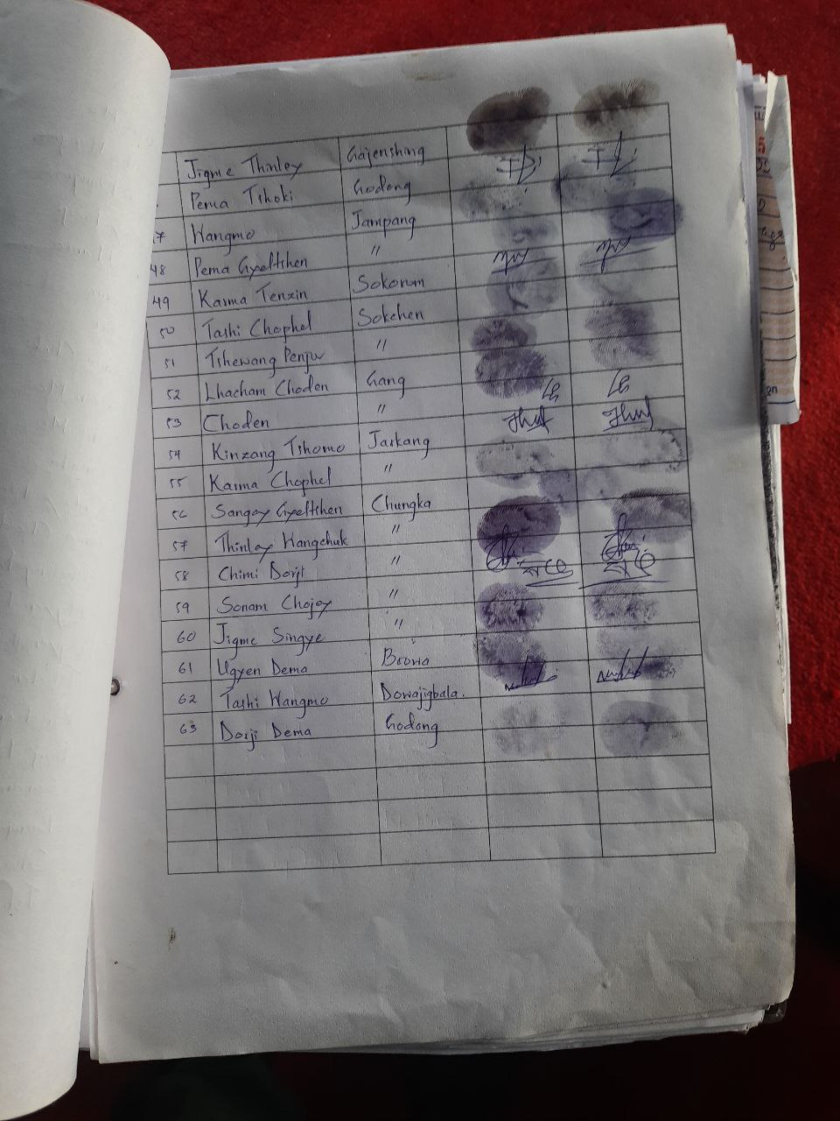

Annexure II: Block description for Borinda grossa

Annexure III: Bock description for Daphne bholua
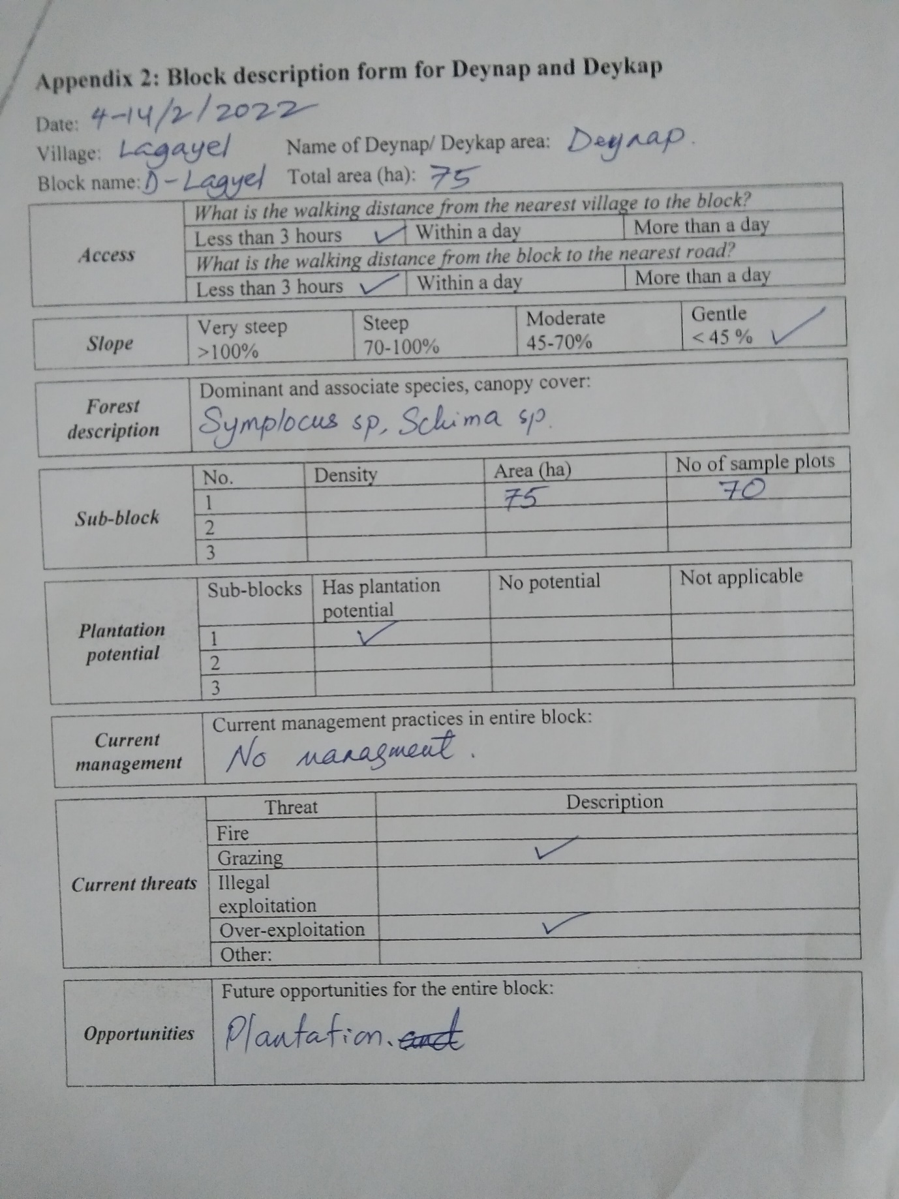

Annexure IV: B. grossa data analysis

Annexure V: D.bholua data analysis

Annexure VI: Data Collection Pictures
